FINNISH LUTHERAN CHURCH CELEBRATES FINLAND 100

APRIL 23, 2017

at 8504 13th Ave NW, Seattle, WA 98117

SERVICE AT 10:00 AM

CONCERT PROGRAM AT 11:15 AM

FOLLOWED BY PITOPÖYTÄ LUNCHEON

Concert and Luncheon $ 15 for adults, $7 for 7-12 yrs,
Children under 7 free

Visiting Pastor Jorma Pesonen from Finland

Church Choir with Maria Mannisto

Ida Elina on Kantele

"Children of War"
compiled by the Nordic Heritage Museum

About Ida Elina:
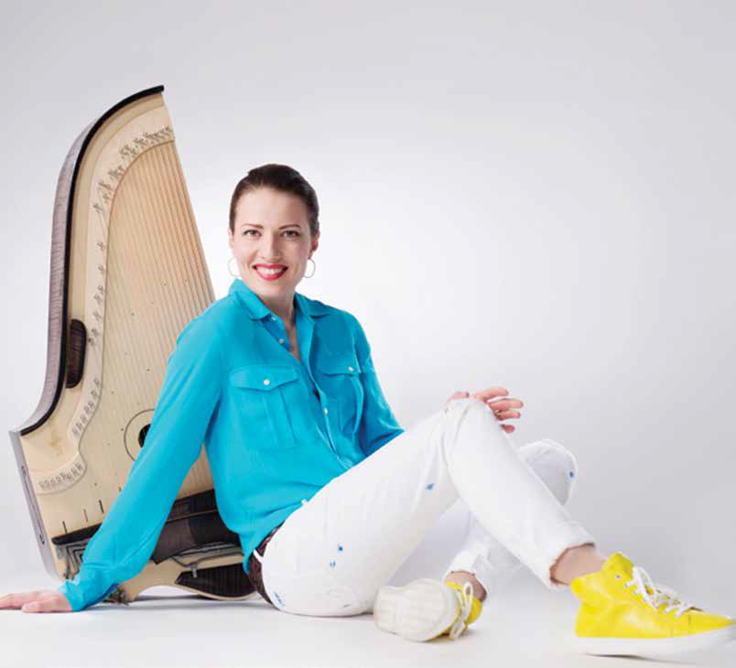
As one of Finland’s leading kantele performers,
Ida Elina enthralls audiences of all ages with
her unique style as she interprets contemporary
music and traditional Finnish tunes in new ways.
The singer-songwriter was inspired by slap
guitar playing to take Finland’s ancient stringed
instrument to new levels, in both her performance
style and wide-ranging repertoire.
Come and enjoy the versatility, virtuosity, and
vocal talent of the world’s first pop-kantele player.
Ida Elina is one of the performers sponsored by
Finlandia Foundation National and its Finland
100 Music Program, celebrating the centennial of
Finland’s Declaration of Independence.

